**DAILY ONLINE ACTIVITIES SUMMARY**

|  |  |  |  |  |  |  |  |  |
| --- | --- | --- | --- | --- | --- | --- | --- | --- |
| **Date:** | **26-05-2020** | | | | | **Name:** | **Ijaz Ibrahim** | |
| **Sem & Sec** | **4th A** | | | | | **USN:** | **4AL18CS026** | |
| **Online Test Summary** | | | | | | | | |
| **Subject** | | **Design and Analysis of Algorithms** | | | | | | |
| **Max. Marks** | | **30** | | **Score** | | | **25** | |
| **Certification Course Summary** | | | | | | | | |
| **Course** | **Career Edge-Knockdown the Lockdown** | | | | | | | |
| **Certificate Provider** | | | **TCS** | | **Duration** | | | **15 days** |
| **Coding Challenges** | | | | | | | | |
| **Problem Statement: Two java programs and 1 C programs** | | | | | | | | |
| **Status: Executed** | | | | | | | | |
| **Uploaded the report in Github** | | | | | **Yes** | | | |
| **If yes Repository name** | | | | | **https://github.com/ijazibrahim/DailyReport.git** | | | |
| **Uploaded the report in slack** | | | | | **Yes** | | | |

Online Test Details: (Attach the snapshot and briefly write the report for the same)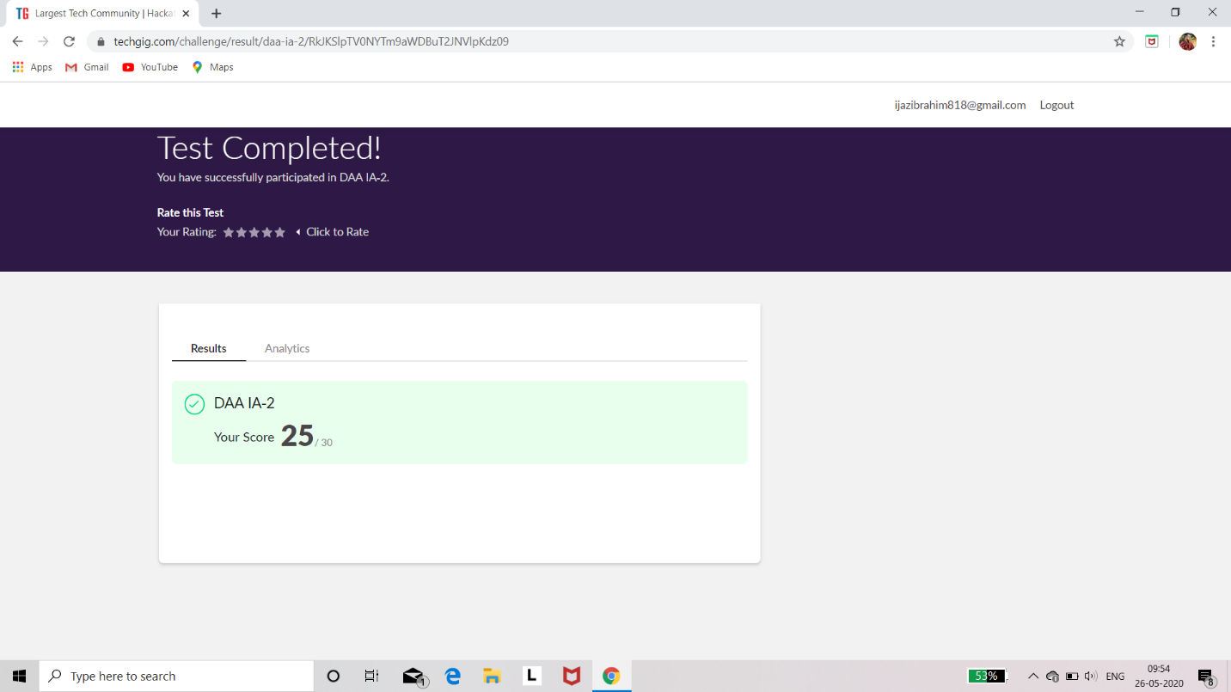

Certification Course Details: (Attach the snapshot and briefly write the report for the same)

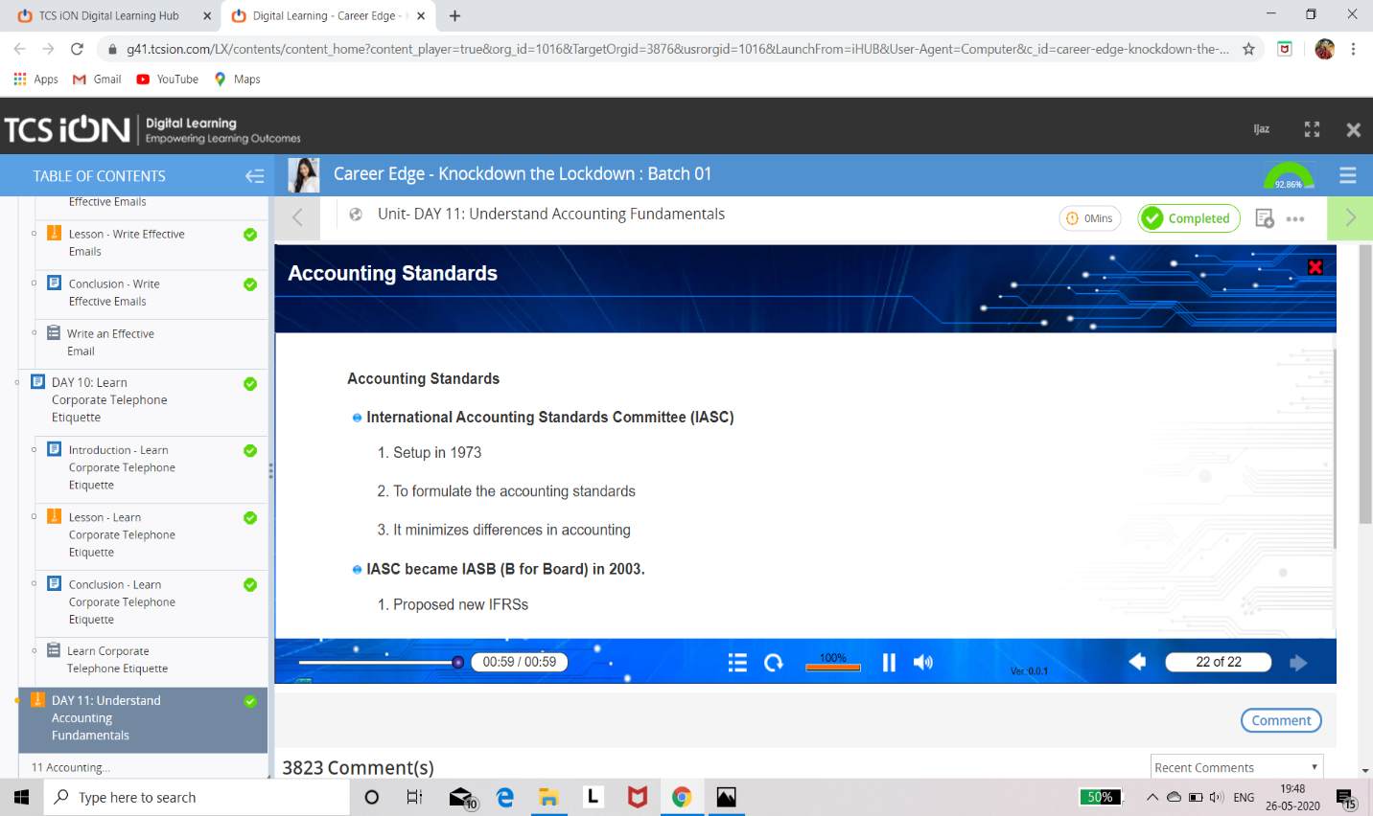

Coding Challenges Details: (Attach the snapshot and briefly write the report for the same)

Program1:

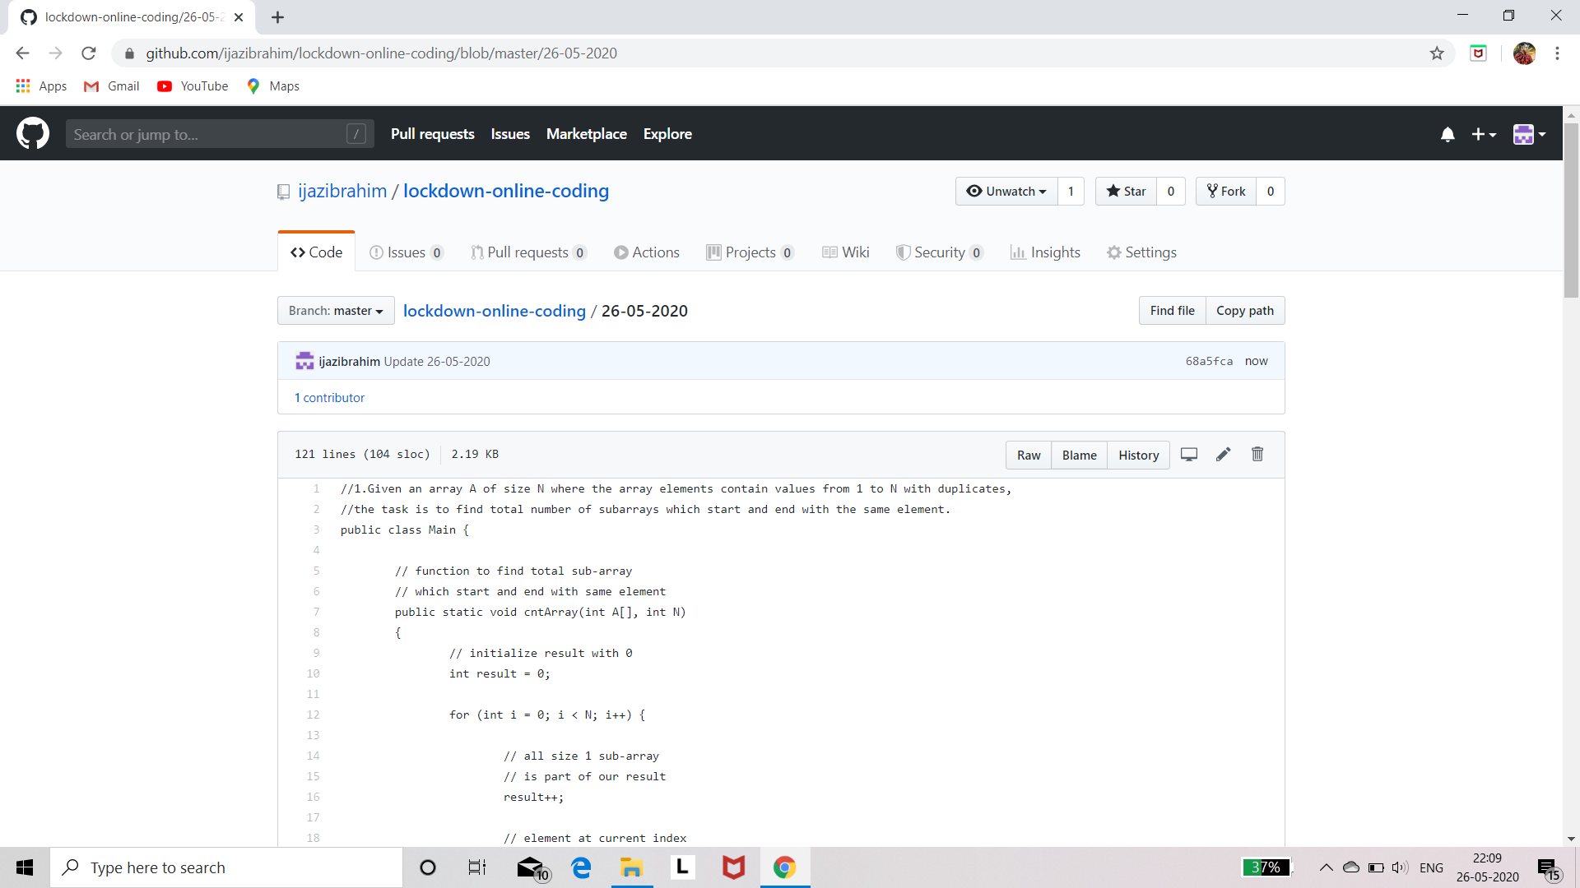

Program2:

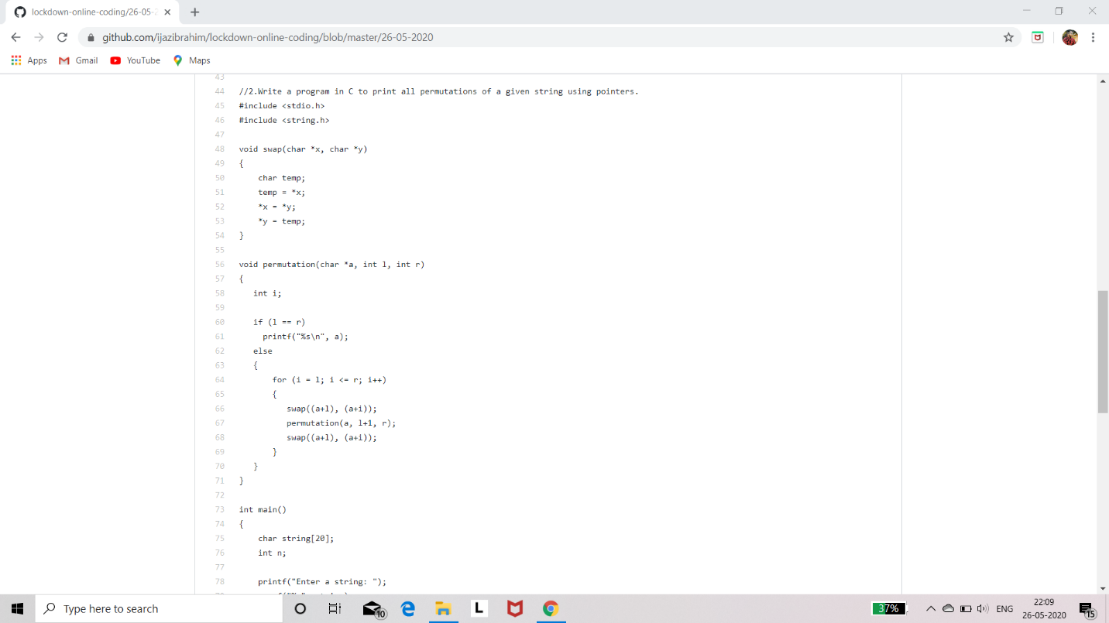

Program3:

